**Git Hub Repo Guide**

**Create new repository:**

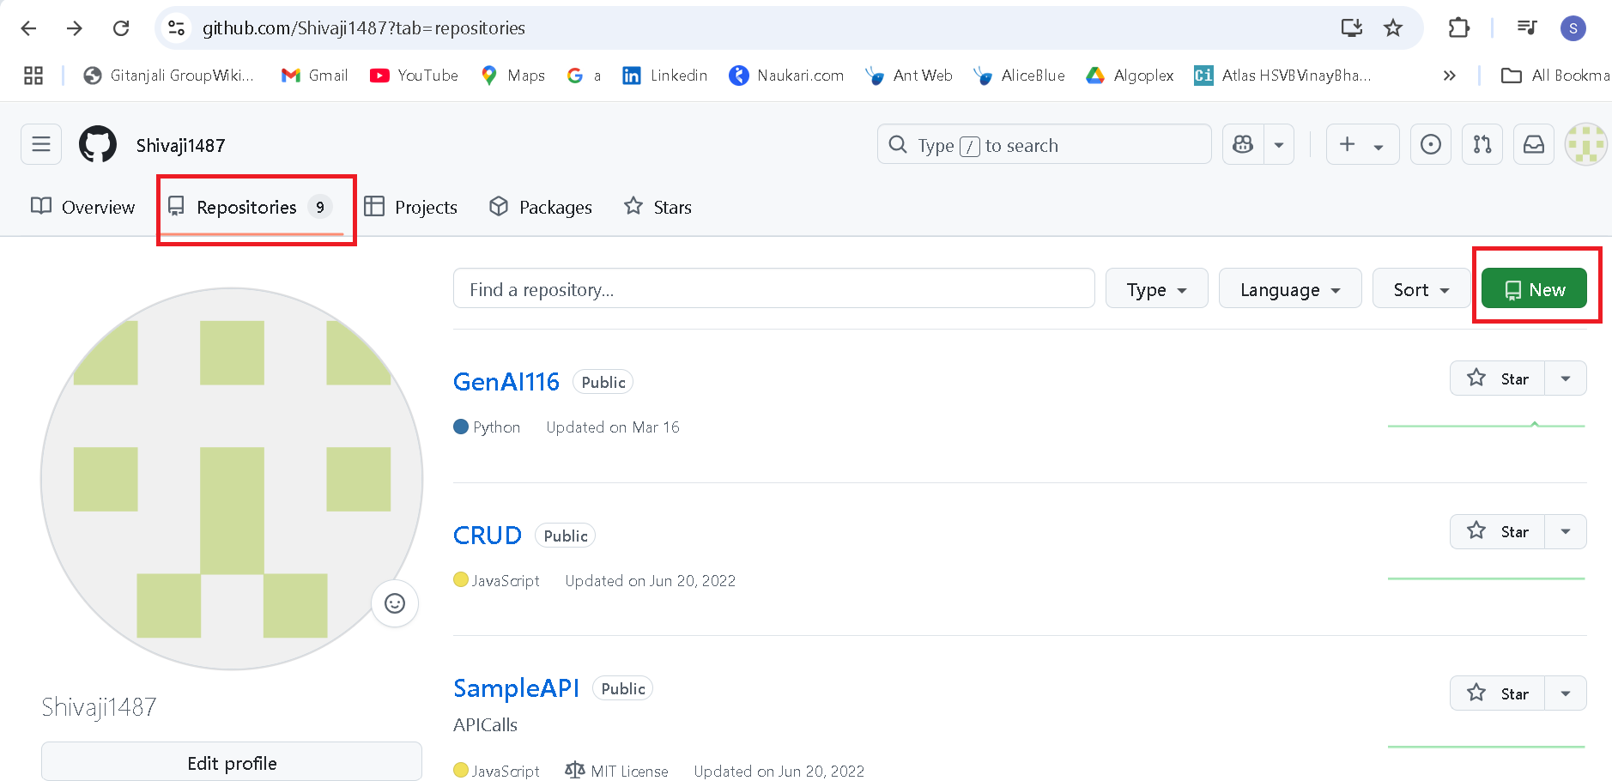

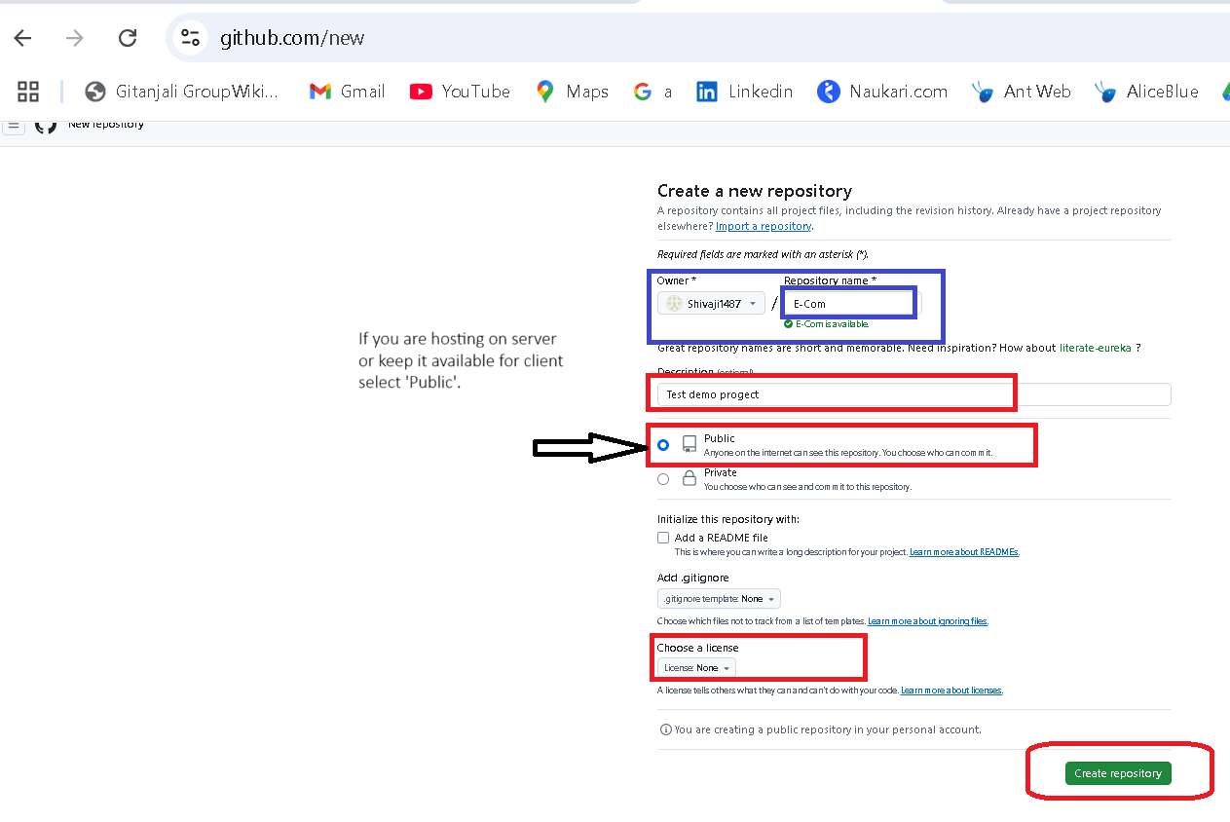

Go to the folder path where you created your project folder, write click and select ‘**Open Git bash here**’ and run🡪 $ git init

Xyz@LAPTOP-K0RDCQ74 MINGW64 ~/OneDrive/Desktop/e-Com (master)

$ git init another hidden directory will created as (.git)

Initialized empty Git repository in C:/Users/Xyz/OneDrive/Desktop/e-Com/.git/

Hidden directory will display if ‘Hidden Items’ is checked

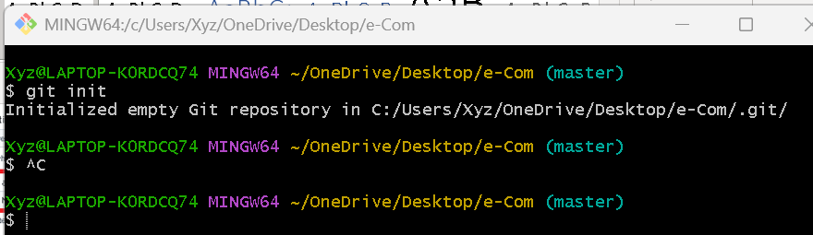

The repository created on my system is called Local repository and the repository created on web site called remote repository (Many people can access it)

**Upload a file on git via command**

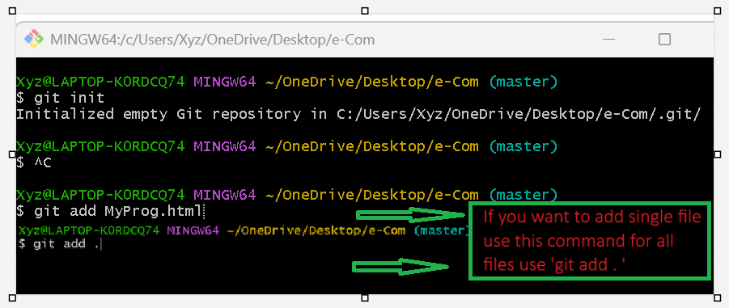

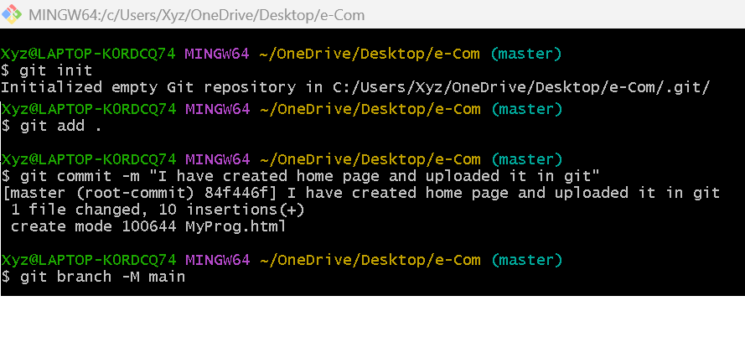

Use command as ‘git remote add origin and paste URL path from git account’

**…or create a new repository on the command line**

echo "# Shivaji1487" >> README.md

git init

git add README.md

git commit -m "first commit" #use ‘-m’ for commit the changes and put message

git branch -M main

git remote add origin https://github.com/Shivaji1487/Shivaji1487.git

git push -u origin main

**…or push an existing repository from the command line**

git remote add origin https://github.com/Shivaji1487/Shivaji1487.git

git branch -M main # change the name as main with ‘-M’

git push -u origin main # upload the files and this will ask for authentication

Commit and push the code into existing file, MyProg.html file is already stored into local directory and I have made the changes into the same existing directory and then I have to commit and upload the changes follow below steps.

Git add MyProg.html

Git add .

Git commit -m “Make web page more interactive”

Git push -u origin main (main is master directory on git hub)

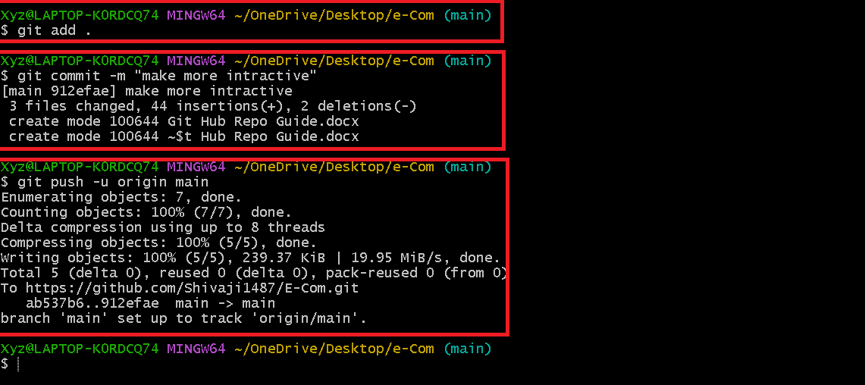

**How do I restore the changes in existing file in GIT**

**Suppose you have made the changes in existing file and that file can be in staging phase but you use below command to revert the changes**

1. **for single file: git restore index.html**
2. **for all files: git restore .**



**If your file name have spaces use ‘git restore "Git Hub Repo Guide.docx"’**